**Reaction Rates**

Reaction rate can be measured in 2 ways:

1. By measuring the **rate of disappearance of products**.
2. By measuring the **rate of appearance of products**.

According to collision theory, in order for a reaction to occur:

* Reactant particles must **collide**.
* Reactant particles must collide with the **activation energy**.
* Reactant particles must collide with **correct orientation**.

Activation energy: The **minimum energy** required to reach the **transition state** in a reaction.

Transition state (activation complex): A **highly unstable** arrangement in a reaction where **bond-breaking and bond-forming is occurring**; a momentary arrangement which has the **highest enthalpy** for the reaction.

* As bond strength increases, activation energy increases.
* As bond number increases, activation energy increases.
* As activation energy increases, the rate of reaction decreases.

Factors that affect reaction rate:

* Temperature:

Increasing temperature increases the **average kinetic energy** of the particles, increasing the proportion of particles that have **sufficient kinetic energy to meet the activation energy** required for a **successful collision**, hence increasing the **reaction rate**.

Increasing temperature increases the **average kinetic energy** of the particles, causing them to move **faster** and in doing so increase the **rate of collisions** that occur, hence increasing the **reaction rate**.

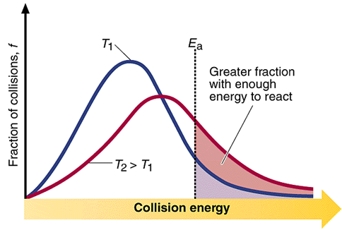

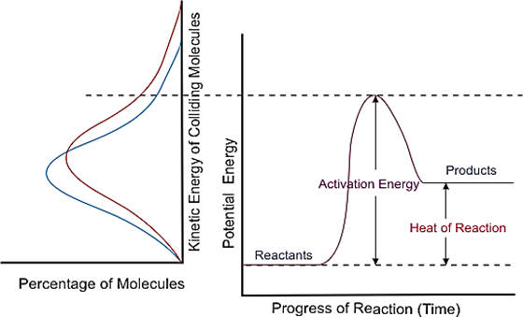

* Concentration:

Increasing the concentration of the reactants causes the **distance between the particles** to decrease. This increases the **rate of collisions** that occur, hence increasing the **reaction rate**.

* Pressure:

Increasing the pressure of the reactants causes the **distance between the particles** to decrease. This increases the **rate of collisions** that occur, hence increasing the **reaction rate**.

* State of subdivision:

Increasing the surface area of the reactants exposes more reactant particles to each other at one time, increasing the rate of collisions that occur, hence increasing the reaction rate.

* Catalysts:

Catalysts provide an **alternate pathway with a lower activation energy**. This means that a greater proportion of particles will have **sufficient kinetic energy** to meet the **activation energy** required for a successful collision, hence increasing the **reaction rate**.

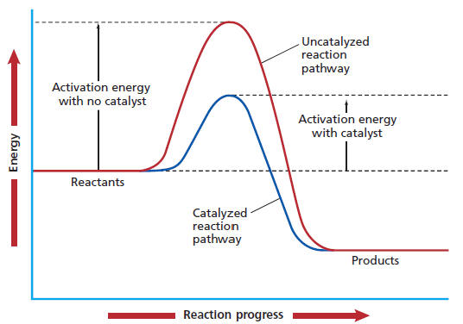

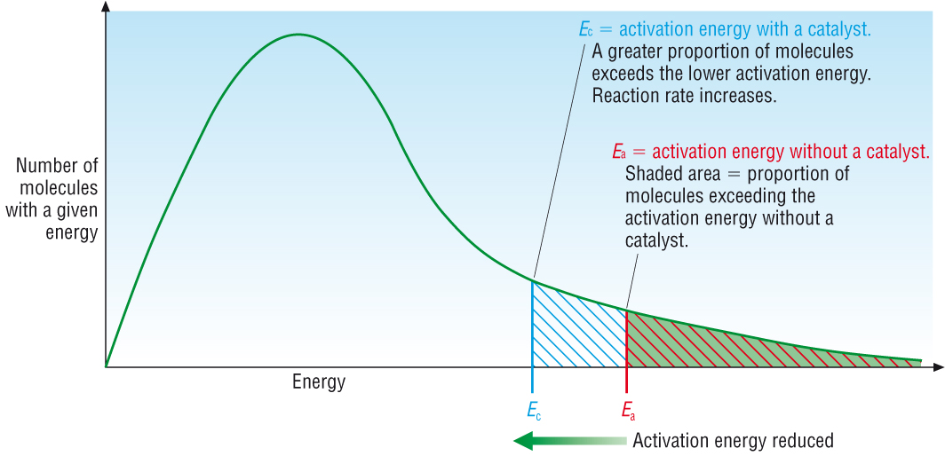

Enzyme: A protein that acts as a specific biological **catalyst**.

Substrate: The specific **reagent molecule(s)**.

Enzyme specificity: The ability of an enzyme to **catalyse** a specific reaction.

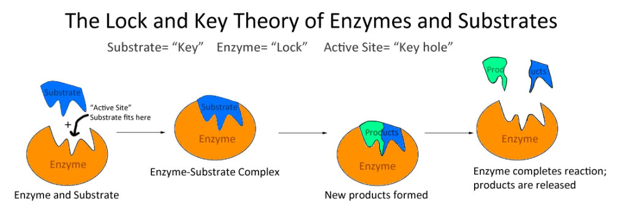

Nanocatalysts have a large surface area to volume ratio, **maximising contact between the catalysts and reactants**.

Benefits include:

* Large **surface area to volume ratio**.
* Large **surface area to mass ratio**.
* Requires much **less** of the expensive platinum.
* Can be manufactured on a **large scale** using a “green” method of production.